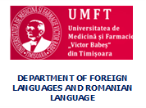
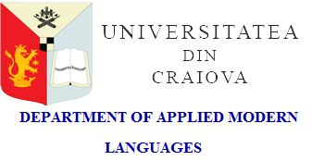

WORKSHOPS WITH NATIONAL AND INTERNATIONAL STUDENT PARTICIPATION
Timișoara, 21-24 April 2020

Please complete the registration form and send it to the coordinating professors or to one of the addresses below by March 31st, 2020.
frinculescu.iulia@umft.ro
or
staicu.simona@umft.ro

REGISTRATION FORM

Surname:
First name:
Specialization/Major in:
Year of study:
E-mail address:
Title of the workshop
Title of the presentation

